KS01 -

Functionality
A cost centers is an organizational unit within a controlling area that represents a clearly delimited area of responsibility where costs are monitored against a budget.
The costs incurred by your organization should be transparent. Cost Center Accounting lets you analyze the overhead costs according to where they were incurred within the organization. A cost center can be included in more than one group for reporting and cost allocation. Cost centers are created with “Valid from/ to dates” of: 01.01.1900 to 31.12.9999.

Scenario

This Transaction is used to create a new cost center.

Requirements
Standard hierarchy must exist.

Menu Path | Accounting → Controlling → Cost Center Accounting → Master Data → Cost Center → Individual Processing → KS01 - Create
Transaction Code | KS01

1. Double Click on KS01 - Create

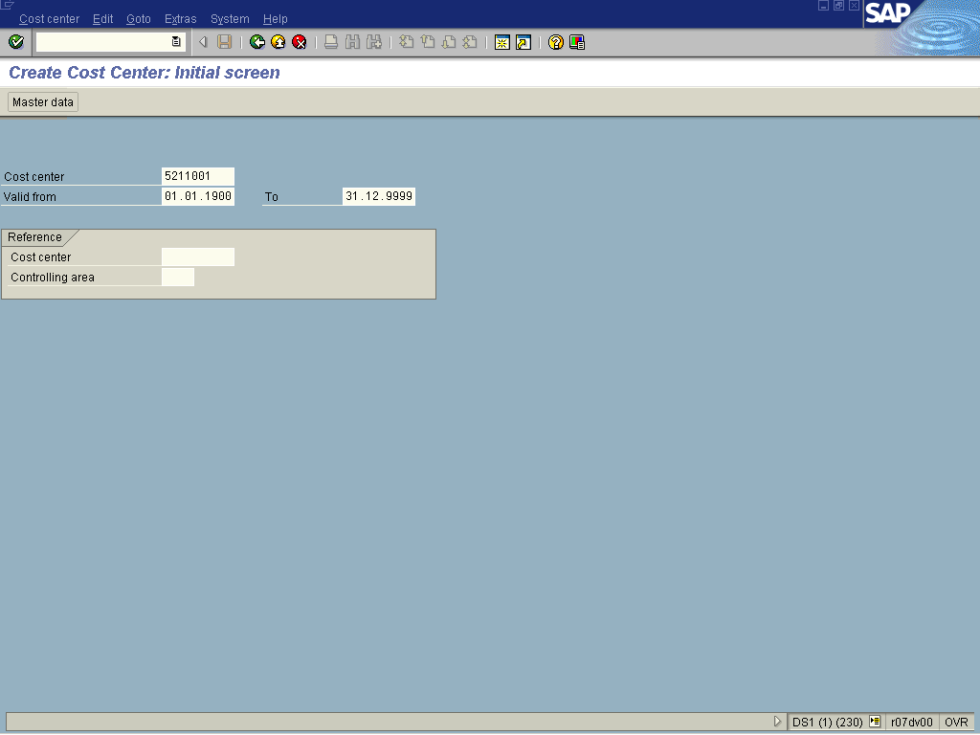

2. Update the following fields:

Field Name | Field Description | Values
Cost center | Organizational unit within a controlling area that represents a defined location of cost incurrence. | Example: 5211001

3. Click

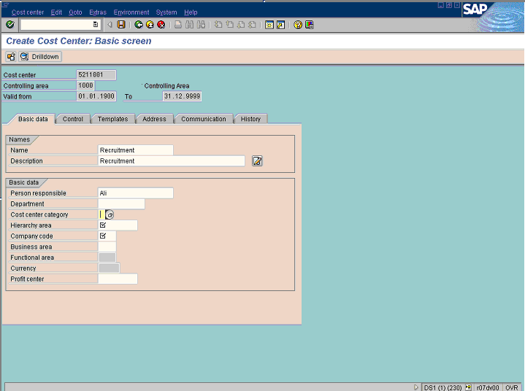

4. Update the following fields:

Field Name | Field Description | Values
Name | The cost center name is used for online displays and evaluations that do not have enough space for the cost center description. | Example: Recruitment
Description | Brief text description of the cost center. The cost center description is used for online displays and evaluations that have sufficient space. | Example: Recruitment
Person responsible | Description of the Person responsible for managing the cost center. | Example: Ali

5. Click Cost center category Button .

Restrict value range (1) 9 Entries found

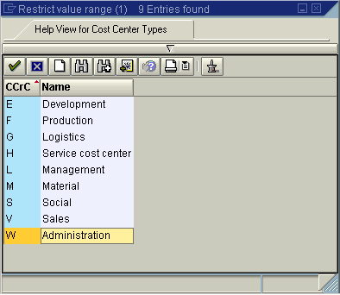

6. Select W - Administration in list box.

7. Click Enter .

Note: Activity types are also assigned to categories. If required, this functionality allows limitation of cost centers to certain categories only.

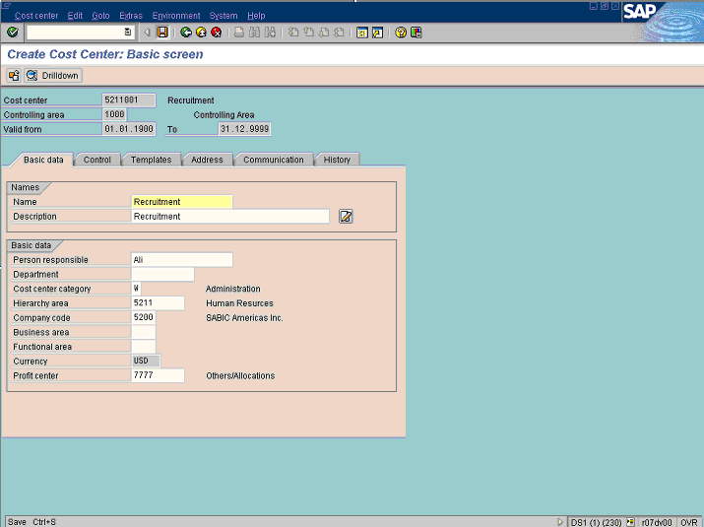

8. Update the following fields:

Field Name | Field Description | Values
Hierarchy area | Tree structure for organizing the business processes belonging to a controlling area from the Controlling (CO) standpoint. | Example: 5211
Company code | The smallest organizational unit for which a complete self-contained set of accounts can be drawn up for purposes of external reporting. | Example: 5200
Profit center | Organizational unit in Accounting that reflects a management-oriented structure of the organization for the purpose of internal control. | Example: 7777

9. Click Enter to validate the entry.
10. Click Save

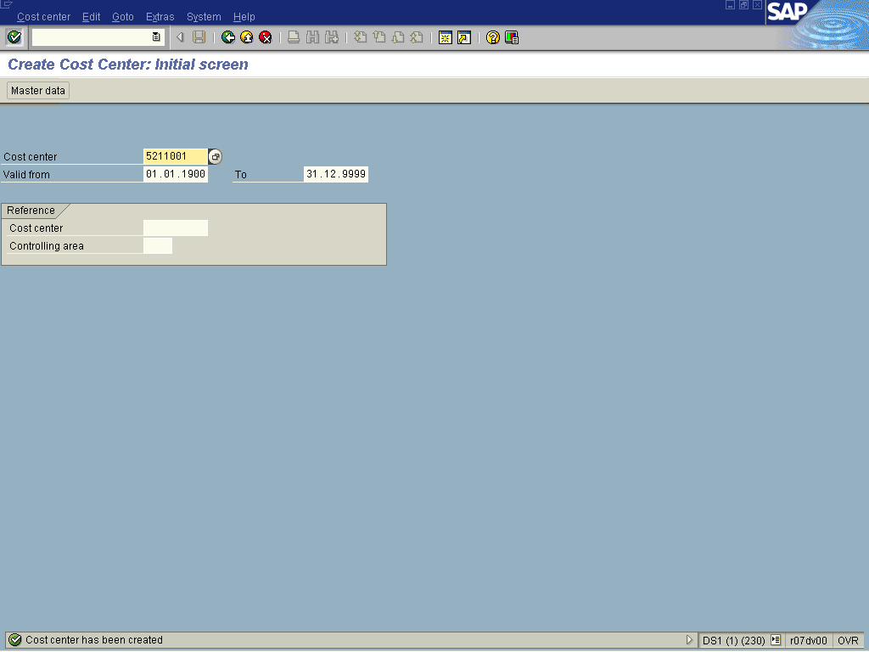

11. The message bar displays “Cost Center has been created”

